FAMILY LIFE IN BRITAIN
Read an translate the text. Try to find the differences between British way of family life and traditions of family life in our country.

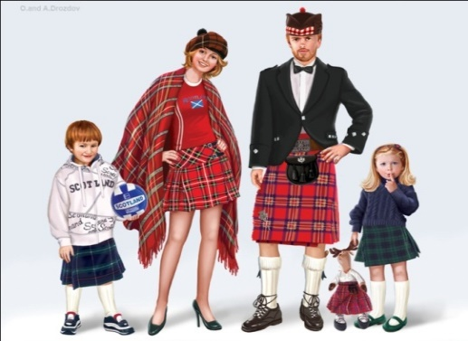
A "typical" British family used to consist of mother, father and two children. But in recent years there have been many changes in family life. For example, since the law made it easier to get a divorce, the number of divorces has increased. That's why 24% of British children live with only one parent, usually their mother.
The contemporary British child doesn't have a lot of companionship from brothers and sisters, because the average family has only one or two children. Most British children live with their parents at least until they finish school at the age of 17 or 18. Then many go away to college, leaving some parents sad and lonely in their empty nest and others enjoying their release from parental responsibilities. But many adults stay with their parents during their college years or return home after graduation. Today's parents cannot even be sure that their married children have moved out forever. After a divorce they may return to the parental home temporarily or even on a long-term basis.
Older people take pride in their independence, enjoy their freedom and don't want to be a burden to their children. The telephone, the car and the airplane keep them in close contact even when they live in different parts of the country.
Members of family - grandparents, aunts, uncles, cousins keep in touch, but they see less of each other than they used to. This is because people often move away from home town to work and so the family becomes scattered. Christmas is the traditional season for reunions. Although the family group is smaller nowadays than it used to be, relatives often travel many miles in order to spend holidays together. Family parties may be all the more joyous when they bring together relatives who haven't seen each other for a while.

