NORTHERN IRELAND

Read and translate the text.

Motto: | «Quisseparabit» – «Who will separate us»
Flag: | 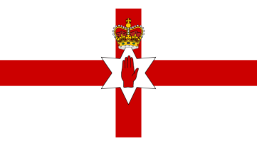
National Day: | 17 March
Area: | 14,130sq km
Population: | 1.850.393
Nationality: | English, Irish
Climate: | Mild and damp
Capital city: | Belfast
Major cities: | Londonderry, Armagh, Derry,  Lisburn and Newry
Anthem: | «God Save The Queen», «The Soldier’s Song»
Official Language: | English, Irish, Ulster Scots
Main religions: | Catholic Church of Ireland, Methodist
Currency: | Pound Sterling £
Highest Point: | SlieveDonard (850 m), the Mourne Mountains
Longest Rivers: | the Shannon (360 m),  the Barrow (192 km)
Largest Lakes: | Loch Neagh(396sq km),  Loch Corrib (176 sq km)
Official flower: | Shamrock

Northern Ireland, also known as Ulster, is considered to be a wonderful part of the United Kingdom. Northern Ireland was created in 1921, when Ireland was partitioned between Northern Ireland and Southern Ireland by an act of the British Parliament. Southern Ireland became an independent republic, Eire.
Northern Ireland is a land of mountains, rivers and lakes. It is situated in the north-eastern part of the island of Ireland including Rathlin Island and several smaller offshore islands. The country is washed by the North Channel and by the Irish Sea. The population of Northern Ireland is about 1.7 million people.
Northern Ireland consists of 6 counties of Antrim, Armagh, Down, Fermanagh, Londonderry, and Tyrone. They are also known as Ulster, though the territory does not include the entire ancient province of Ulster.  Northern Ireland has a temperate maritime climate. It’s wetter in the west than in the east of the country, although cloud cover is persistent across the region. Most of the land of  Northern Ireland is covered with rich green grass, which is a result of damp climate and extensive deforestation in the 16th and 17th centuries. | 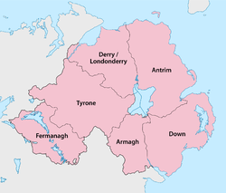
Belfast is the capital and the largest city of Northern Ireland. Belfast stand on the coast. It was founded in 1603. Nowadays it is the most important port and commercial and industrial centre.
Londonderry is the second largest city in Ulster, it has a Navy and port. The city received its name in 1609 when the confiscated lands of the native chieftains were given to some of the London companies and the Corporation of London. The companies took the prefix “London” to the existing town of Derry. Now it is known as the most western town of the United Kingdom and Northern Ireland. Among other major cities are Armagh, Derry, Lisburn and Newry.
Northern Ireland has always had an industrial economy with shipbuilding, rope manufacture and textiles being the main industries. However, heavy industry has been replaced by services. Tourism also plays an important role in the local economy.
Northern Ireland has developed its own culture. There are lots of theatres and cinemas in the country. There are two national museums: the Ulster Museum in Belfast, which houses a collection of Irish antiquities and the Ulster Folk and Transport Museum. The Ulster Symphony Orchestra is among the leading orchestras of Britain.

