WALES

Read and translate the text.

Motto: | “Cymru am byth” – “Wales for ever”
Flag: | 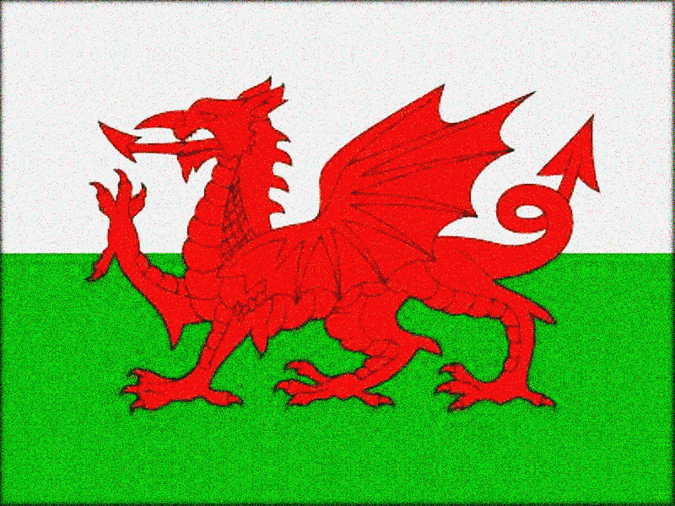
National Day: | 1 March
Area: | 20,779 sq km
Population: | 3mln
Nationality: | Welsh and British
Climate: | Maritime
Capital city: | Cardiff
Major cities: | Swansea, Newport
Anthem: | «Land of My Fathers»
Official Language: | English, Welsh
Main religions: | Anglicanism, Methodism
Currency: | Pound Sterling £
Highest Point: | Snowdon (1085 m)
Longest River: | the Towy (103 km)
Largest Lake: | the Bala (4.4 sq km)
Official animal: | Dragon
Official flower: | Daffodil, leek

Wales is the country in the west of Great Britain. It is washed by the Gulf Stream and has a mild climate, with more rain than most of Britain. The land is unsuitable for arable farming, but sheep and cattle thrive. The highest mountain in England and Wales is Snowdon (1085 m). The largest natural lake is the Bala. The longest river is the Wye (130 miles).
Cardiff, the largest city of Wales, is the capital of the country. It is situated on the southeast coast of Wales, and three rivers, theTaff, the Ely and the Rhymney flow through it into the Bristol Channel. Castles abound in and around Cardiff. Cardiff is home for the National Museum of Wales, the Welsh Industrial Maritime Museum, the City Hall, Lladaff Cathedral and many other fine buildings.
Swansea is the second Welsh city. It is set along the wide, curving bay. The city centre was rebuilt after heavy bombing in World War II.
The Welsh have managed to maintain their ancient language. The Welsh language belongs to the Celtic languages and is the earliest of the British Languages. There is an official bilingual policy: road signs are in Welsh and English. Today it is taught in schools and colleges, radio and TV programmes, many official documents are in English and Welsh.

